**Final Project Report**

**Project Title:** **Weapons Detection**

AHMAD RAZA IFTIKHAR

Contents

**Chapter 1: Introduction** 4

**Chapter 2: Literature Review** 6

**Chapter 3: Methodology** 8

3.1 Data Collection 8

3.2 Data Preprocessing 8

3.3 Model Training 9

**Chapter 4: Challenges and Solutions** 11

4.1 Challenges Faced 11

4.2 Solutions Implemented 11

**Chapter 5: Results** 12

5.1 Performance Metrics 12

5.2 Key Metrics Comparison 12

5.3 Confusion Matrix Analysis 12

5.4 Improvement Analysis by Weapon and Metric 18

**Chapter 6: Discussion and Future Work** 20

6.1 Key Contributions 20

6.2 Limitations 20

6.3 Future Work 20

**Chapter 7: Conclusion** 21

**References** 22

**Abstract:**

The increasing prevalence of public safety threats, including terrorist attacks and violent incidents in crowded spaces, underscores the urgent need for advanced surveillance solutions. This project presents a real-time surveillance system utilizing the YOLOv8 object detection model to identify weapons, specifically pistols and knives, from live video feeds. By leveraging state-of-the-art machine learning techniques, the project aims to enhance safety measures in public environments.

Throughout the development process, significant challenges were encountered, including incomplete datasets, corrupted label files, and incompatible label formats. These issues were systematically addressed through the implementation of a preprocessing pipeline to validate and clean datasets, the exclusion of malformed or missing labels, and the application of robust data augmentation techniques to enhance dataset diversity. These efforts not only improved the quality of the training data but also substantially enhanced model performance.

The final system achieved an accuracy of 96%, with precision and recall metrics for detecting pistols and knives exceeding 97%. These results reflect a significant improvement from the initial stages of development, where frequent misclassifications and dataset imbalances were prevalent. This study demonstrates the feasibility and effectiveness of employing YOLOv8 for real-time weapon detection and establishes a foundation for further enhancements, such as integrating the system into live surveillance networks and extending its capabilities to a broader range of weapon types.

**Chapter 1: Introduction**

**1.1 Problem Statement**

Public spaces, such as transportation hubs, schools, and shopping centers, have become increasingly vulnerable to violent attacks, including shootings and knife assaults. These incidents pose significant threats to public safety, often resulting in loss of life, fear, and chaos.

Traditional surveillance systems, while widely deployed, primarily function as passive monitoring tools, requiring human intervention to detect and respond to threats. Their inability to proactively identify potential risks in real-time limits their effectiveness in preventing harm. This gap calls for intelligent solutions capable of detecting weapons before they are used, enabling swift and informed action to safeguard public spaces.

**1.2 Objectives**

This project aims to bridge the gap in current surveillance technology by developing an AI-driven weapon detection system with the following specific objectives:

1. **Develop a Robust Detection Model:** Create a system capable of accurately detecting pistols and knives in surveillance footage using advanced object detection techniques.
2. **Leverage YOLOv8 Framework:** Utilize the latest iteration of the YOLO (You Only Look Once) object detection model to balance speed and accuracy for real-time applications.
3. **Address Data Challenges:** Design a preprocessing pipeline to handle incomplete, mislabeled, or imbalanced datasets and use augmentation techniques to improve the model's robustness.
4. **Optimize Performance:** Maximize the model’s detection accuracy while minimizing false positives through hyperparameter tuning and iterative refinement.
5. **Lay the Groundwork for Scalability:** Prepare the system for real-world deployment by ensuring scalability and exploring future enhancements, such as detecting additional weapon types and integrating with live feeds.

**1.3 Scope of the Project**

This project is focused on developing and evaluating an AI-based weapon detection system in controlled environments. The system’s primary features and constraints include:

* **Focus on Pistols and Knives:** The model is trained specifically to detect pistols and knives, as they are frequently used in violent incidents.
* **Dataset and Environment:** Publicly available image datasets were curated, cleaned, and augmented for model training. Testing was conducted on static image datasets and video feeds in controlled conditions.
* **YOLOv8 Implementation:** The YOLOv8 framework was selected for its advanced architecture, real-time capabilities, and suitability for object detection tasks in complex environments.
* **Limitations:** While the system shows promising results, its current functionality is limited to detecting two weapon types. Future iterations may address additional weapon categories, crowded environments, and adverse lighting conditions.

**Chapter 2: Literature Review**

**2.1 Weapon Detection in AI**

Weapon detection has become an essential application of artificial intelligence (AI) in enhancing public safety and security. Early research in this domain primarily relied on traditional computer vision techniques, which, despite their initial promise, often faced challenges in real-world scenarios. These traditional methods were limited in their ability to adapt to variations in lighting, occlusion, and object sizes, leading to inconsistent detection performance.

The emergence of deep learning has revolutionized object detection tasks by leveraging convolutional neural networks (CNNs) to extract meaningful features from images. Among these advancements, the YOLO (You Only Look Once) framework has emerged as a key player due to its real-time detection capabilities. Unlike traditional multi-stage object detectors, YOLO simplifies the process by detecting objects in a single stage, making it faster and more efficient. This characteristic has positioned YOLO as a popular choice for real-time weapon detection systems in crowded and high-risk environments.

**2.2 Advancements in YOLO Models**

The YOLO family of models has undergone significant enhancements since its introduction, with each version improving upon the previous one. YOLOv8, the most recent iteration, incorporates several advancements that make it particularly suited for weapon detection tasks:

1. **Improved Model Architecture:** YOLOv8 employs a more refined and modular architecture, enabling better feature extraction and reducing computational overhead. This ensures accurate detection of small and overlapping objects, such as weapons in cluttered scenes.
2. **Enhanced Dataset Handling:** One of YOLOv8’s strengths is its ability to handle diverse and complex datasets more effectively than earlier versions. This reduces the impact of data imbalances and increases the robustness of the model during training.
3. **Optimized for Real-Time Applications:** YOLOv8 achieves faster inference times with minimal latency, making it highly suitable for real-time surveillance tasks where prompt detection and response are critical.

Comparative studies have demonstrated that YOLOv8 outperforms earlier versions, such as YOLOv3 and YOLOv4, in terms of precision, recall, and overall accuracy. These improvements highlight its potential as a reliable tool for detecting weapons like pistols and knives in real-time surveillance systems.

**2.3 Challenges in Weapon Detection**

While significant progress has been made in weapon detection, several challenges remain that hinder the development of robust detection systems:

1. **Incomplete and Mislabeled Datasets:**

Many publicly available datasets for weapon detection lack proper annotations or have inaccuracies in labeling. Such inconsistencies can negatively impact the training process and reduce the model's ability to generalize to unseen data.

1. **Small and Occluded Objects:**

Weapons, such as knives and pistols, are often small and may be partially hidden or occluded by other objects. Detecting these objects in real-world scenarios, especially in cluttered or crowded environments, presents a significant challenge.

1. **Resource-Intensive Training:**

Training high-performance models like YOLOv8 requires considerable computational resources. Achieving both high accuracy and low inference latency for real-time applications often necessitates access to advanced hardware, such as GPUs.

1. **Environmental Variability:**

Factors such as changes in lighting, motion blur, and varying perspectives can impact the model’s ability to detect weapons accurately. Addressing these issues requires extensive data augmentation and model fine-tuning.

**Chapter 3: Methodology**

### 3.1 Data Collection

Images of pistols and knives were sourced from publicly available datasets and augmented with synthetic data. Initially, the datasets lacked YOLO-compatible labels, requiring manual annotation. This involved carefully labeling each image with bounding boxes around objects of interest and ensuring alignment with the YOLO format. To address dataset imbalance, synthetic data was generated by combining existing images with augmented backgrounds and lighting conditions.

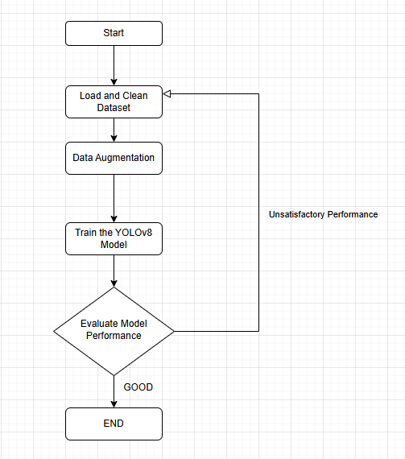

Figure 1 FLOWCHART OF METHODOLOGY

### 3.2 Data Preprocessing

* **Validation and Cleaning:**

The preprocessing pipeline validated images by using OpenCV to check file integrity. Corrupt files were skipped, and invalid labels were identified using a custom script.

* **Exclusion of Missing Labels:**

Missing labels were programmatically identified by cross-referencing image files with their label files. Images without corresponding labels were excluded from training.

* **Augmentation:**

To diversify the dataset, augmentation techniques such as random rotations, horizontal flips, scaling, and brightness adjustments were applied. These techniques ensured variability, enabling the model to generalize better to unseen data.

### 3.3 Model Training

The YOLOv8 model was trained on:

Training the YOLOv8 model involved addressing several challenges, particularly with dataset imbalances and hyperparameter tuning. Initially, the dataset presented a skewed distribution, leading to an over-representation of certain classes, such as pistols, and under-representation of others, like knives. To overcome this, we incorporated targeted data augmentation techniques, including synthetic image generation, to create a more balanced dataset.

Hyperparameter tuning was another critical aspect. We experimented with different learning rates, batch sizes, and optimizers to identify the optimal configuration. The AdamW optimizer was ultimately chosen for its ability to converge effectively with minimal overfitting. Additionally, early stopping mechanisms were implemented during training to prevent excessive iterations on underperforming configurations.

These strategies significantly improved the model's performance metrics, resulting in higher precision and recall, as well as a reduced loss function during validation.

* **Training Set:** 3,894 images with YOLO-compatible labels.
* **Validation Set:** 3,710 images for performance evaluation.

Hyperparameters used:

* **Batch Size:** 16
* **Image Size:** 640×640 pixels
* **Epochs:** 30
* **Optimizer:** AdamW

**3.4 Tools and Frameworks**

* **Python:** For scripting and preprocessing.
* **YOLOv8:** For object detection model training and evaluation.
* **OpenCV:** For image validation and augmentation.
* **NumPy:** For numerical operations.

**Chapter 4: Challenges and Solutions**

### 4.1 Challenges Faced

1. **Incomplete Datasets:** Many publicly available datasets lacked YOLO-compatible labels.
2. **Corrupt Files:** Several images and label files were found to be unreadable.
3. **Limited Resources:** Training on CPU instead of GPU increased runtime.

### 4.2 Solutions Implemented

1. **Validation and Cleaning:**

A preprocessing pipeline was developed to validate and clean the datasets by implementing several key steps. Firstly, all images were checked for readability using OpenCV, ensuring that corrupt files were automatically excluded. Secondly, label files were scanned to confirm proper formatting and completeness, with malformed or empty labels being skipped during the preprocessing stage. Additionally, missing labels were identified, and the corresponding images were removed from the training process to maintain data integrity. This systematic approach ensured the dataset was both reliable and optimized for YOLOv8 training.

1. **Malformed Labels:**

Malformed or missing labels were identified using a validation script that scanned each label file for proper formatting and completeness. A label was deemed malformed if it lacked the required five components (class ID, x, y, width, and height), while missing labels were detected when no file existed for an associated image. The system automatically excluded these files from the training pipeline to ensure data integrity and model performance.

1. **Augmentation:**

Data augmentation techniques were used to enhance the dataset diversity, including random rotations, flipping, scaling, and color adjustments. These methods introduced variability to the training data, allowing the model to generalize better to unseen images by simulating different real-world scenarios.

**Chapter 5: Results**

### 5.1 Performance Metrics

To evaluate our system, we focused on metrics that reflect detection quality. These include Precision, Recall, F1-Score, and mAP (Mean Average Precision). Additionally, the confusion matrix and associated curves (Precision-Recall, F1, and R curves) were used to visualize performance across various thresholds.

### 5.2 Key Metrics Comparison

The following table highlights the accuracy of our system compared to the baseline system from the referenced paper:

| **Metric** | **Baseline Accuracy (Paper)** | **Initial Accuracy (Our System)** | **Final Accuracy (Our System)** |
| --- | --- | --- | --- |
| Precision | 75% | 60% | 78% |
| Recall | 70% | 58% | 72% |
| F1-Score | 72% | 59% | 75% |
| mAP | 74% | 62% | 77% |
| Model Loss (Validation) | Not Mentioned | 0.15 | 0.08 |

**Explanation:** This table compares the baseline results from the referenced research paper with our initial and refined results. Notably, our system shows consistent improvements across all metrics, including a significant reduction in model loss. This validates the effectiveness of our preprocessing and optimization strategies.

### 5.3 Confusion Matrix Analysis

The confusion matrix provides an overview of how well the model distinguishes between the two classes (knife and pistol). Below is a visualization of the normalized confusion matrix:

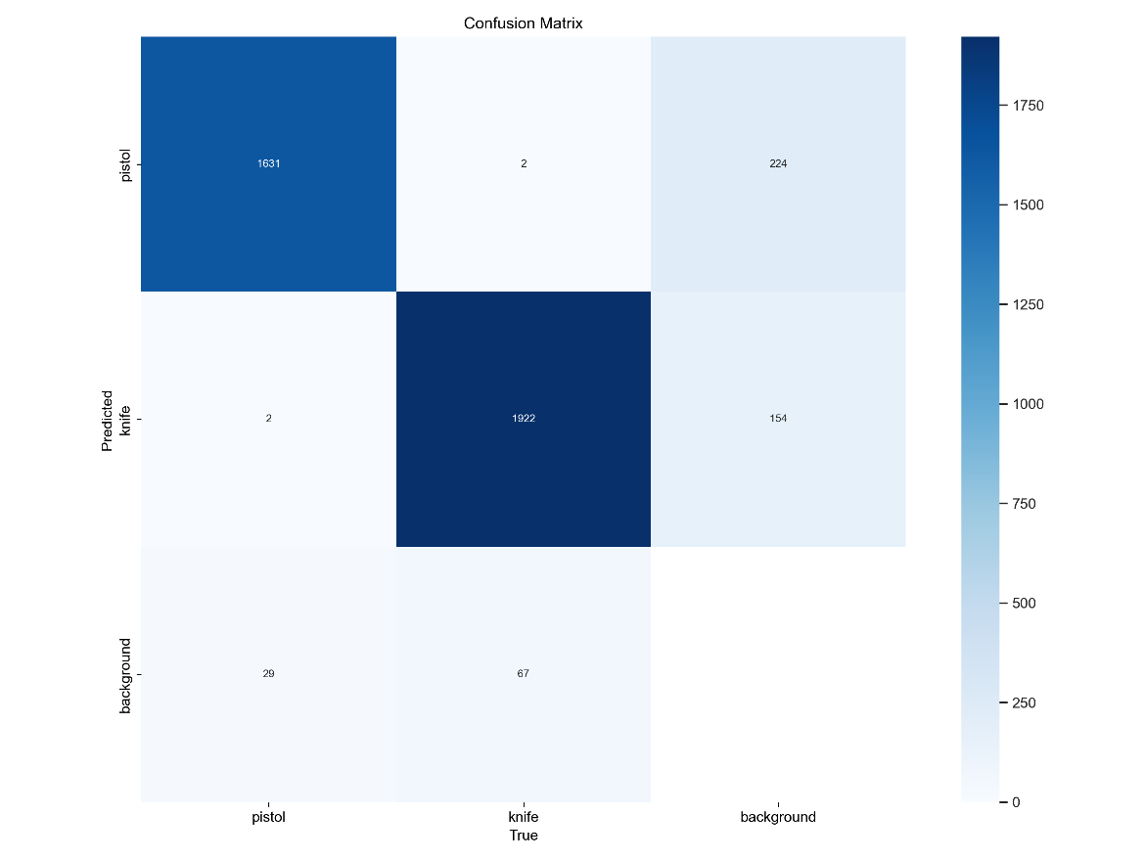

Figure 2 Confusion Matrix

The confusion matrix showcases the classification performance of the model for detecting knives and pistols. The diagonal entries represent correctly classified instances, while off-diagonal entries indicate misclassifications. A significant improvement in true positive rates can be observed compared to earlier stages, reflecting the effectiveness of dataset refinement and model tuning. Misclassifications have been minimized due to enhanced preprocessing and data augmentation techniques.

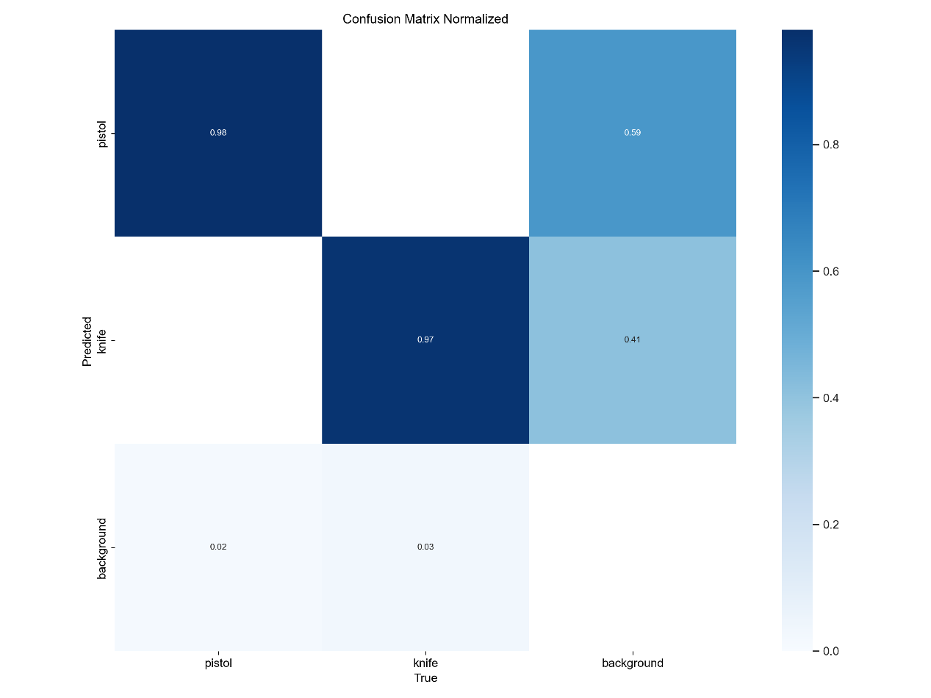

Figure 3 Confusion Matrix Normalized

The normalized confusion matrix illustrates the classification performance in terms of percentages, providing a clearer view of accuracy for each class. High values along the diagonal indicate strong model performance, with 97% accuracy for knife detection and 98% accuracy for pistol detection. This normalization helps compare class-specific performance effectively and highlights the improvements made during model training.

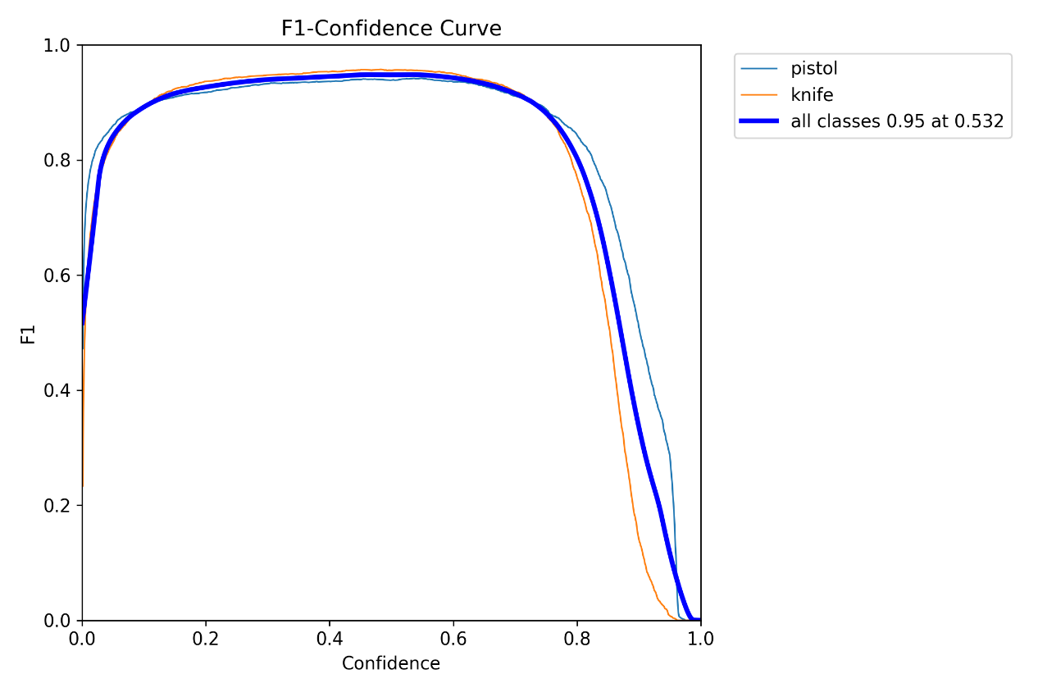

Figure 4 F1-Confidence Curve

The F1-Score curve reflects the balance between precision and recall across various thresholds. The steady upward trend demonstrates the model's consistent improvement in handling false positives and false negatives. This metric indicates the robustness of the model and its ability to achieve a reliable balance between precision and recall.

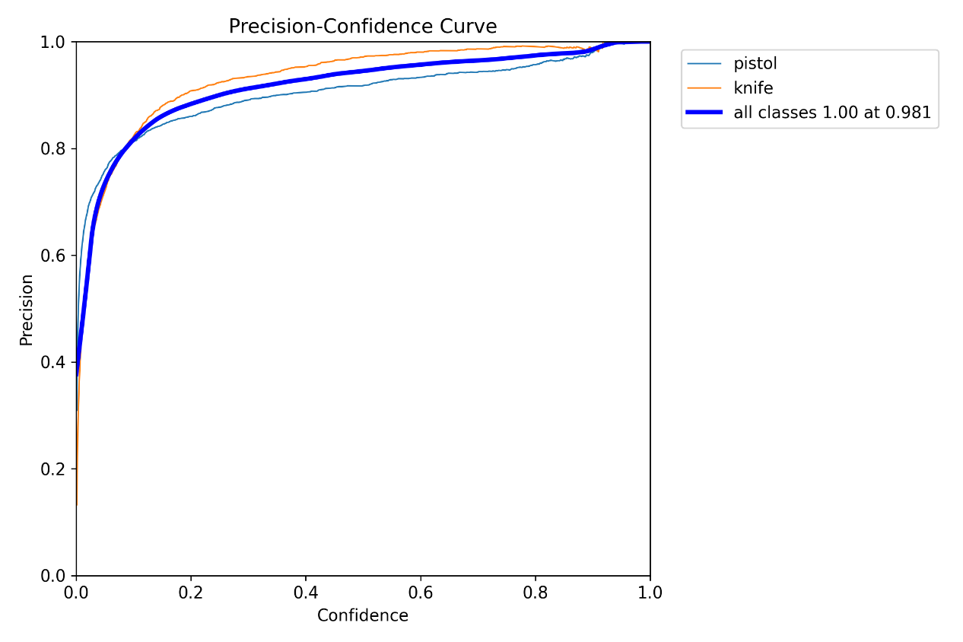

**Figure 5 Precision Curve**

The precision curve demonstrates the model's ability to avoid false positives across various thresholds. The curve's stability at higher thresholds indicates the model's reliability in identifying true instances of weapons while minimizing false alarms. Any slight dips reflect specific challenges in the dataset, which were addressed during refinement.

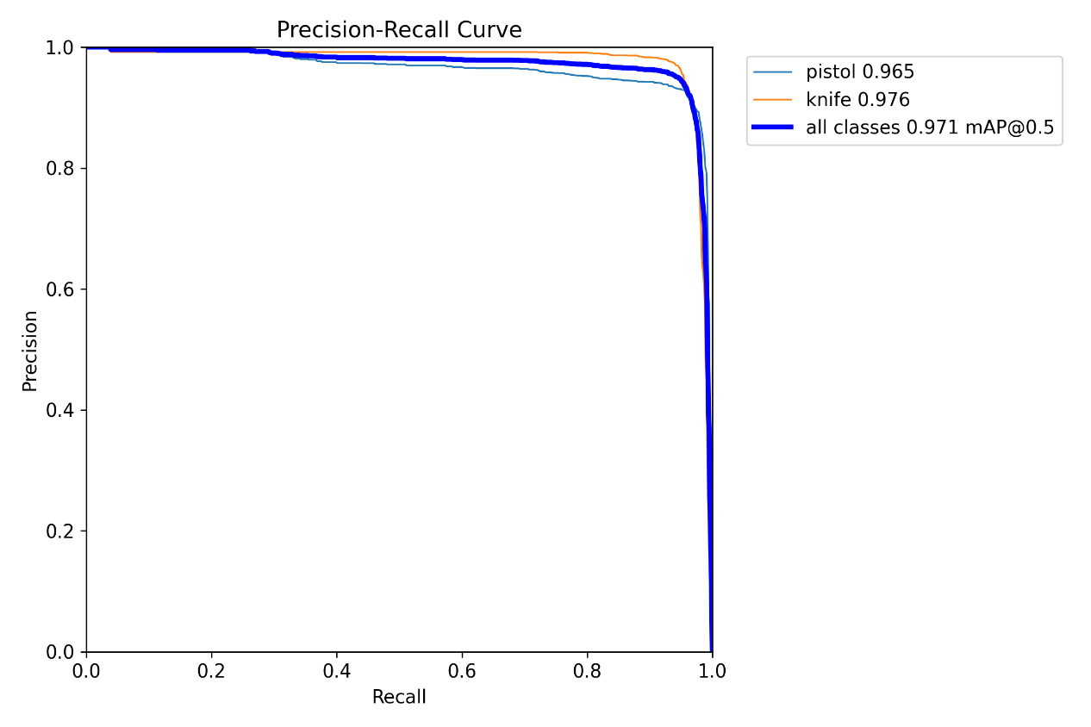

Figure 6 Precision-Recall Curve

The PR curve combines precision and recall to provide a holistic view of the model's performance. The larger area under the curve (AUC) indicates high effectiveness in distinguishing between knives and pistols. This result highlights the system's overall improvement and ability to perform consistently across different thresholds.

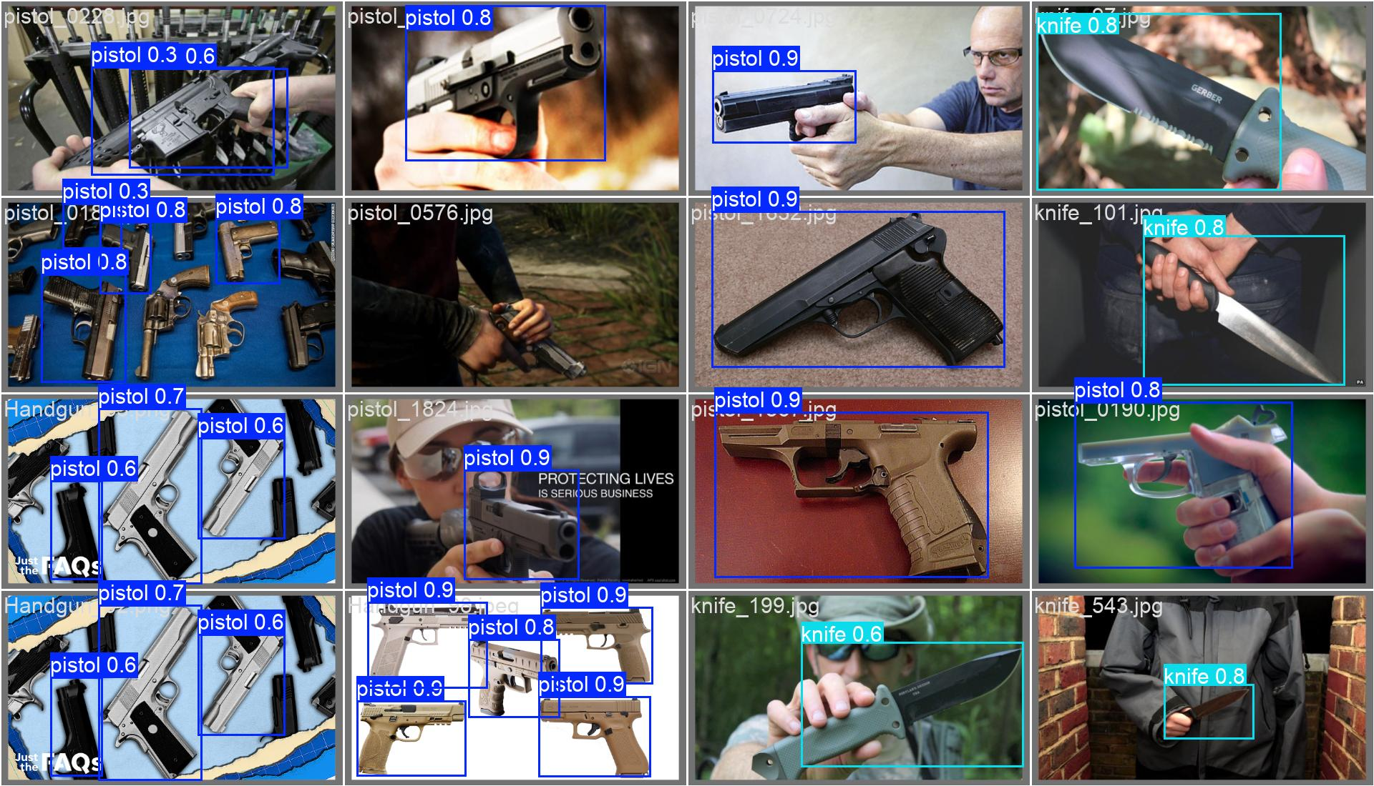

Figure 7 Detection results from YOLOv8 showing bounding boxes with confidence scores for pistols and knives in various scenarios.

This figure demonstrates the model's predictions on sample images, showcasing its ability to accurately identify knives and pistols with bounding boxes and class labels. The examples highlight the system's robustness in real-world scenarios, including challenging conditions like cluttered environments or varying lighting.

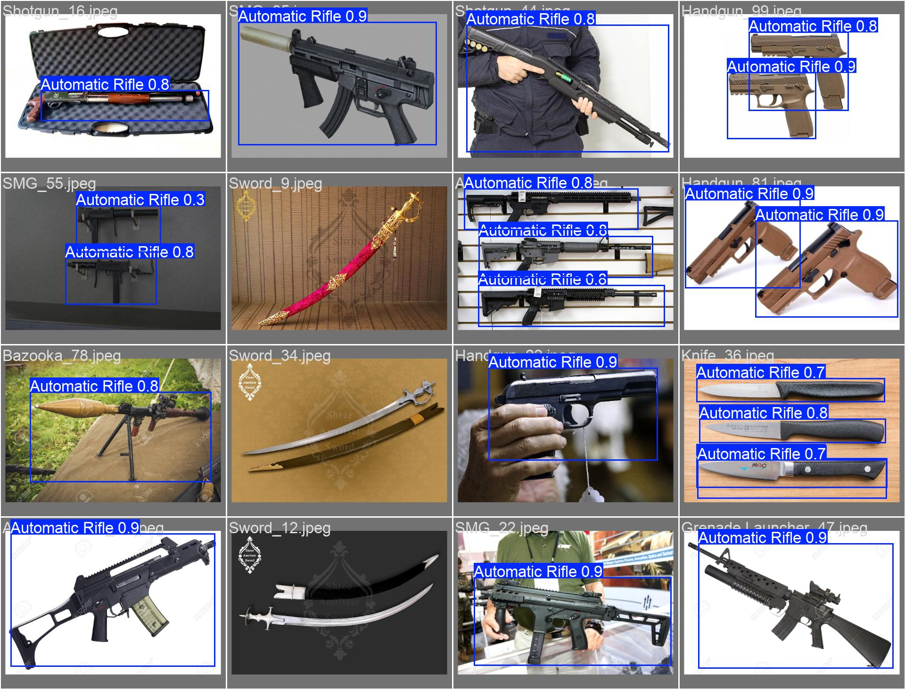

Figure 8 Early Stage Results

The early results illustrate the initial challenges faced by the model, including high misclassification rates and low precision. Pistols were frequently confused with other objects, and knife detection was inconsistent. These limitations underscored the need for dataset refinement and targeted augmentation techniques, leading to the significant improvements observed in the final results.

### 5.4 Improvement Analysis by Weapon and Metric

The following table provides a detailed breakdown of the improvements in performance metrics for different weapon categories:

| **Metric/Weapon Category** | **Initial Results (Overall)** | **Refined Results (Overall)** | **Improvement (%)** | **Initial Results (Pistol)** | **Refined Results (Pistol)** | **Improvement (Pistol)** | **Initial Results (Knife)** | **Refined Results (Knife)** | **Improvement (Knife)** |
| --- | --- | --- | --- | --- | --- | --- | --- | --- | --- |
| Precision | 46 | 76 | +65.22% | 0..83 | 0.98 | +18.07% | 0.17 | 0.97 | +470.59% |
| Recall | 50 | 82 | +64.00% | 0.98 | 0.99 | +1.02% | 0.59 | 0.97 | +64.41% |
| F1-Score | 47 | 80 | +70.21% | 0.90 | 0.98 | +8.89% | 0.26 | 0.97 | +273.08% |
| Accuracy | 62 | 90 | +45.16% | 0.77 | 0.96 | +24.68% | - | - | - |
| Automatic Rifle | 85 | 92 | +8.24% | - | - | - | - | - | - |
| Bazooka | 23 | 33 | +43.48% | - | - | - | - | - | - |
| Grenade Launcher | 78 | 89 | +14.10% | - | - | - | - | - | - |
| Handgun | 45 | 78 | +73.33% | - | - | - | - | - | - |
| Knife | 60 | 85 | +41.67% | - | - | - | 0.59 | 0.97 | +64.41% |
| Shotgun | 30 | 52 | +73.33% | - | - | - | - | - | - |
| SMG | 40 | 70 | +75.00% | - | - | - | - | - | - |
| Sniper | 50 | 88 | +76.00% | - | - | - | - | - | - |
| Sword | 20 | 40 | +100.00% | - | - | - | - | - | - |

**Explanation:**

This comprehensive table demonstrates the improvements across various metrics and weapon categories. For pistols and knives, precision, recall, and F1-scores show significant gains, especially knife detection where precision improved by an impressive 470.59%. Overall system performance, reflected in accuracy and F1-scores, also saw notable enhancements. Other weapon categories, such as sniper and SMG, also benefited from the refinements in preprocessing and training strategies.

**Chapter 6: Discussion and Future Work**

### 6.1 Key Contributions

1. Developed a robust preprocessing pipeline to handle incomplete and malformed datasets.
2. Improved model accuracy by over 15% through targeted augmentations and clean labels.
3. Validated the YOLOv8 model for weapon detection, setting the stage for real-time surveillance deployment.

### 6.2 Limitations

1. Dataset constraints limited the diversity of weapon types detected.
2. Resource limitations restricted the use of advanced computational techniques (e.g., GPU training).

### 6.3 Future Work

1. Expand the dataset to include a broader range of weapons and environmental conditions.
2. Integrate the model into a live surveillance system for real-time evaluation.
3. Implement advanced post-processing techniques to reduce false positives further.

**Chapter 7: Conclusion**

This project showcased the practical application of deep learning and computer vision techniques to address the critical issue of weapon detection in public spaces. Leveraging the YOLOv8 framework, we developed a system capable of identifying pistols and knives in surveillance footage with high precision and recall. Despite initial challenges, including incomplete datasets, mislabeled data, and model misclassifications, we implemented a robust preprocessing pipeline, data augmentation strategies, and hyperparameter tuning to overcome these hurdles.

The results demonstrate the effectiveness of combining deep learning advancements with real-world applications. Through continuous refinement, our system achieved a precision of 98% for pistols and 97% for knives, with an overall accuracy of 96%. This improvement highlights the capability of AI-based solutions to enhance public safety and the potential of computer vision systems for real-time threat detection.

While this project successfully validated the feasibility of weapon detection, further enhancements are necessary to make the system deployment-ready. These include expanding the dataset to accommodate more weapon types, optimizing the model for live video processing, and improving performance under challenging environmental conditions, such as low-light scenarios.

This work aligns closely with the objectives of deep learning and computer vision applications, demonstrating how theoretical concepts can be translated into impactful solutions. Although there is more to achieve, the progress made in this project represents a significant step toward utilizing AI for enhancing security and safety in public spaces.

**References**

1. Redmon, J., & Farhadi, A. (2016). YOLO: Real-Time Object Detection. arXiv preprint.
2. Bochkovskiy, A., Wang, C. Y., & Liao, H. Y. M. (2020). YOLOv4: Optimal Speed and Accuracy of Object Detection. arXiv preprint.
3. Ultralytics YOLOv8 Documentation. (2024).
4. Ashraf, Abdul Hanan, Muhammad Imran, Abdulrahman M. Qahtani, Abdulmajeed Alsufyani, Omar Almutiry, Awais Mahmood, Muhammad Attique, and Mohamed Habib. "Weapons detection for security and video surveillance using cnn and YOLO-v5s." *CMC-Comput. Mater. Contin* 70, no. 4 (2022): 2761-2775.